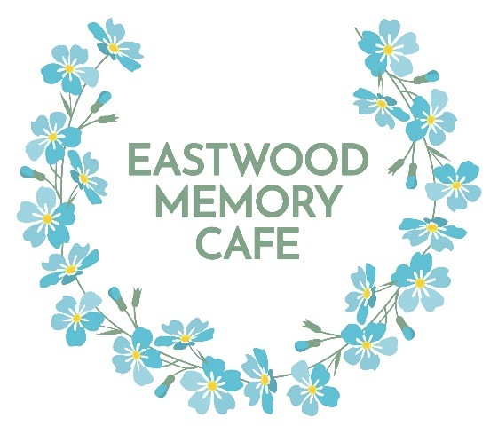
Guest Registration and Consent Form.
Eastwood Memory Cafe is a charity helping and supporting people with dementia and their carers.

Details of accompanying friend, relative, supporter or carer.

Name………………………………………………………………………………………………………………………………………………………………………………………….

Address……………………………………………………………………………………………………………………………………………………………………………………..

………………………………………………………………………………………………………………………………………………………………………………………………………..

Email…………………………………………………………………………………………………..........................................................................................................

Landline Phone number…………………………………………………………………………………………………………………………………………………

Mobile number…………………………………………………………………………………………………………………………………………………………………….

Birthday ……………………………………………………………………………………………………………………….…………………………………………………………

Do you, or you accompanying loved one/friend, have any conditions/allergies we need to know about to keep you safe?
(e.g. diabetes, epilepsy, nut allergy)

……………………………………………………………………………………………………………………………………….……………………………………………………………….

………………………………………………………………………………………………………………………………………………………………………………………………………..

………………………………………………………………………………………………………………………………………………………………………………………………………..

Third Party Emergency Contact Details (for the accompanying friend, relative, supporter or carer) ie next of kin, excluding any named parties on this form.

Name………………………………………………………………………………………………………………………………………………………………………………………….

Contact number…………………………………………………………………………………………………………………………………………………………………..

Relationship……………………………………………………………………………………………………………………………………………………………………………

Details of person with dementia.

Name………………………………………………………………………………………………………………………………………………………………………………………….

Address……………………………………………………………………………………………..........................................................................................................

………………………………………………………………………………………………………………………………………………………………………………………………………..

Birthday………………………………………………………………………………………………………………………….………………………………………………………...

Has a formal diagnosis of dementia been given (from your GP/Consultant)? What type of dementia was diagnosed and approximately when?

………………………………………………………………………………………………………………………………………………………………………………………………………..

If not, has a referral been made by the GP for this?

………………………………………………………………………………………………………………………………………………………………………………………………………..

GP Surgery……………………………………………………………………………………………………………………………………………………………………………..

Hobbies, interests and activities………………………………………………………………………………………………………………………………

Music likes……………………………………………………………………………………………………………………………………………………………………………….

Previous work or skills……………………………………………………………………………………………………………………………………………………..

What activities/information/support would you like us to provide?...........................................................

………………………………………………………………………………………………………………………………………………………………………………………………………

Is there any other information you would like to share with us?

………………………………………………………………………………………………………………………………………………………………………………………………………

………………………………………………………………………………………………………………………………………………………………………………………………………

………………………………………………………………………………………………………………………………………………………………………………………………………..

General Data Protection Regulation

As a charity we hold basic information to help us plan events and activities, communicate information, request feedback and suggestions and send greeting cards.
This includes name, address, telephone numbers, email address, emergency contact details, date of birth and relevant medical and dietary information.
None of this information will be passed to outside sources and is held securely by the Trustees of Eastwood Memory Cafe.

I understand and agree to the above information being held by Eastwood Memory Cafe
Yes/No (please delete as appropriate)

On occasions photographs and videos are taken and are used on the Eastwood Memory Cafe website or Facebook page.
They may also be used for funding applications and occasional local newspaper articles.
Anyone is welcome to request privacy and refuse at any time.

I agree with photographs and videos being taken and published and shared as above.
Yes/No (please delete as appropriate)

Any old or out of date paper information regarding guests, volunteers and visitors will be shredded and details removed from computers and devices.
If you feel there has been a data information breach, you should inform the Chair or Vice Chair and a full investigation will be initiated to ensure all parties are informed and action taken if appropriate.
Permission will be obtained to publish any donation information from all organisations and individuals.
Any changes to the above information and permissions can be requested at any time.

Names……………………………………………………………………………………………………………………………………………………………………………………

Signed……………………………………………………………………………………………………………………………………………………………………………………

Date………………………………………………………………………………………………………………………………………………………………………………………..

Please return the completed form to our correspondence address
Eastwood Memory Cafe, c/o 362 Nottingham Road, Newthorpe, Nottingham, NG16 2ED or email to info@eastwoodmemorycafe.co.uk

Office Use:

Form checked by …………………………………………………..
Details added to onedrive
Consent requested for data.
Consent requested for photos/video.
Emergency contact details given.
Contact added to phone.
Email added to distribution list.
Added to Whatsapp Dementia and Information.
Added to Whatsapp Social.
Birthday recorded.
Lanyards issued.

